**ASSIGNMENT 3**

**AIM:-**

Design at least 10 SQL queries for suitable database application using SQL DML

statements: all types of Join, Sub-Query and View.

**OBJECTIVE:-**

To implement Join and Sub query operations.

**OUTPUT:-**

**PERSON TABLE:**

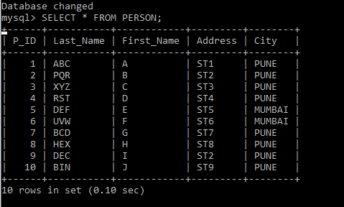

**ORDER_ITEM TABLE:**

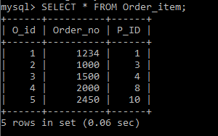

**INNER JOIN:**

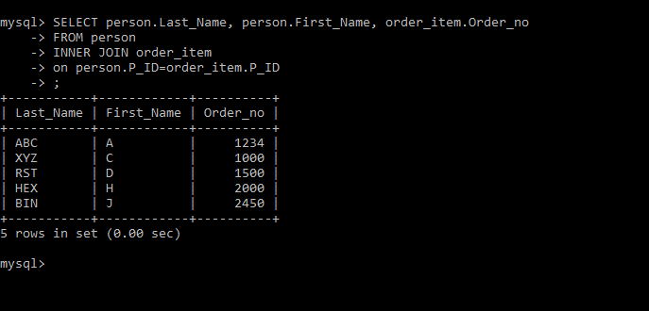

**LEFT JOIN:**

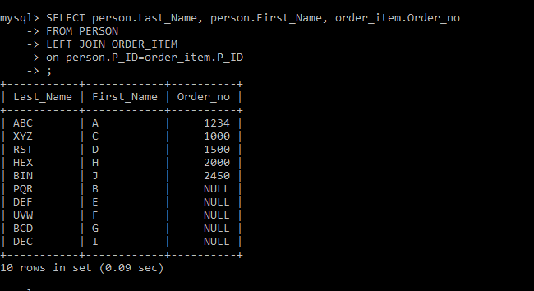

**RIGHT JOIN:**

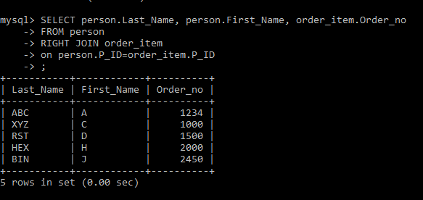

**EMPLOYEE TABLE:-**

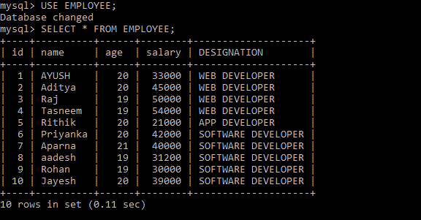

**SUBQUERIES:-**

